Revoice
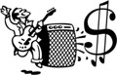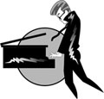
Werner
Mesaboogie (Micro)
E-Gitarre
Keyboard (Stereo o. Mono)

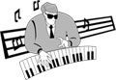
Heinz
Keyboard (Stereo Submischpult)
Lesley-Box (max.3xMicro)

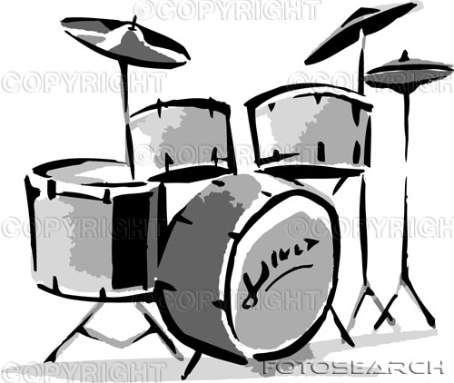
Jochen
Kick
Hihat
Snare
Tom-1
Tom-2
Floor
OH
Vocal
Jörg
Marshall (Micro)
E-Gitarre

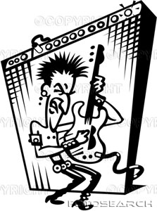

Ralle
Trace Elliot (direkt out)
Bass

Micki
Marshall (Micro)
E-Gitarre
Akkustic Gitarre (Stereo)

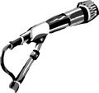
Vocal - Ralle
Vocal - Jörg
Vocal - Matze
Vocal - Micki

